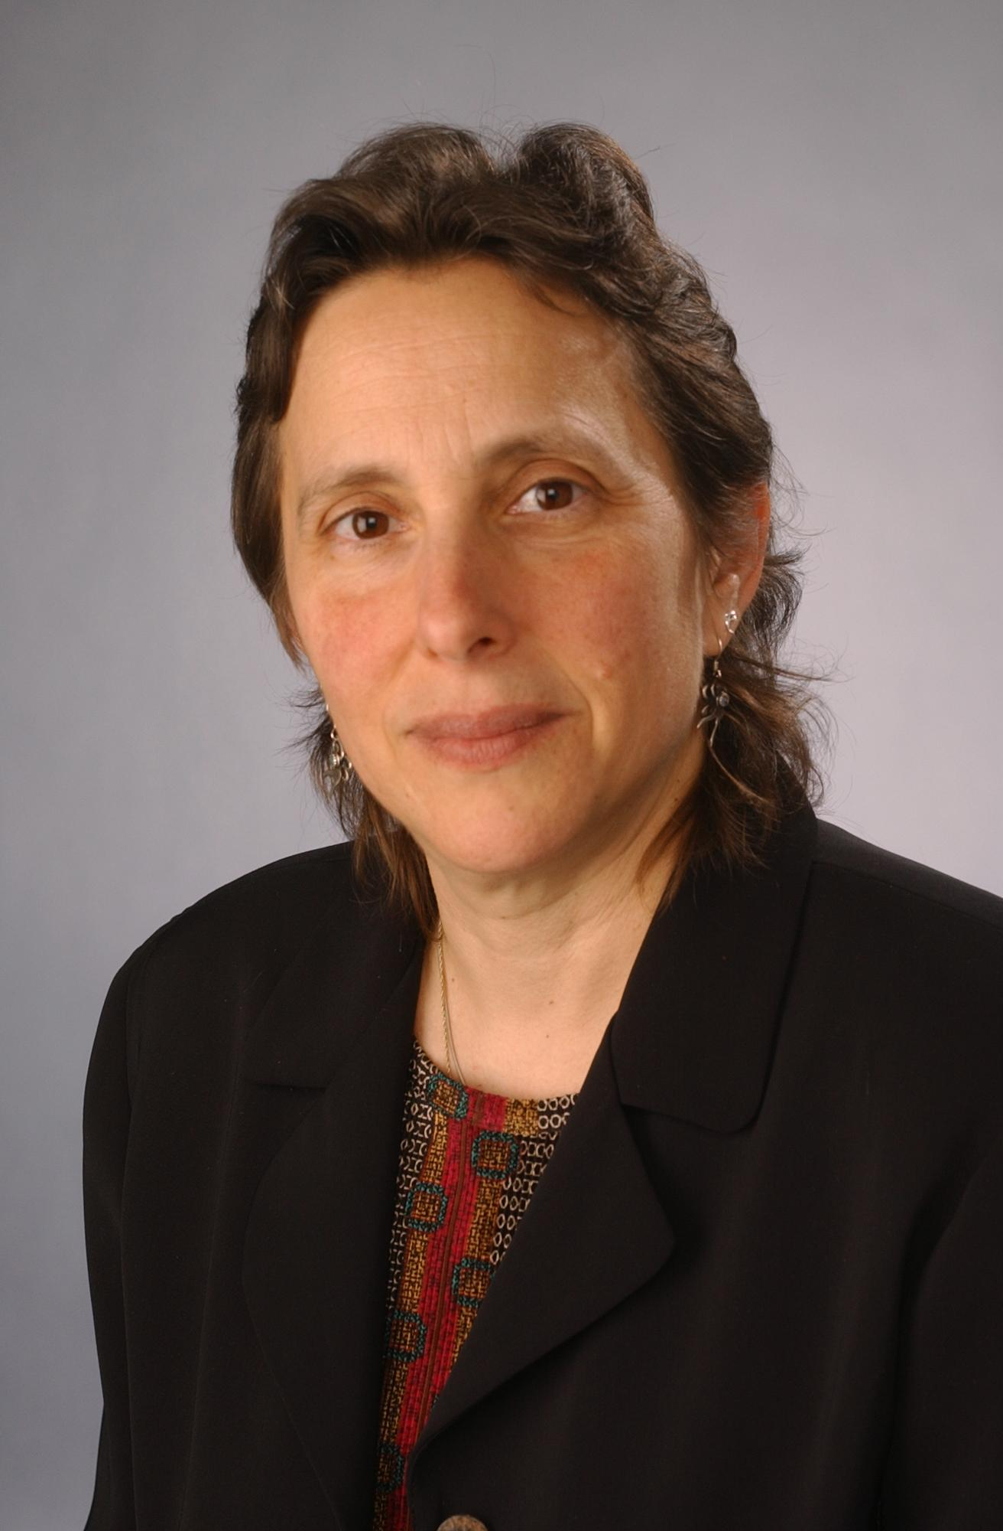
Mara Sapon-Shevin, Ph.D.

Mara Sapon-Shevin is Professor of Inclusive Education in the Teaching and Leadership Department of the School of Education at Syracuse University. She teaches in the University’s Inclusive Elementary and Special Education Teacher Education Program that prepares teachers for inclusive, heterogeneous classrooms.

The author of over 250 books, book chapters and articles, Mara writes extensively about the fields of full inclusion, cooperative learning, social justice education and teaching for diversity.

www.marasapon-shevin.org

Agenda

8:00 am Registration & Continental Breakfast

8:30 Keynote: Mara Sapon-Shevin

10:00 Break

10:20 Keynote: Mara Sapon-Shevin

Noon Lunch

12:45 Breakout Session I

1:45 Break

2:00 Breakout Session II

3:00 Closing

Sponsored by:
Mid-west Regional
Task Force on
Quality Inclusive Schooling

In collaboration with:
- Midwest Regional SETRC
- Midwest Regional S3TAIR Center
- Midwest Regional RSSC
- Regional Early Childhood Direction Center
- Rochester City SETRC
- IHE Consortium
-Greater Rochester Teacher Center Consortium

“Widening the Circle”

A professional development workshop
on the power of inclusion

May 7, 2008
8:00 AM to 3:15 PM

The Burgundy Basin Inn
1361 Marsh Road

Pittsford, NY 14534

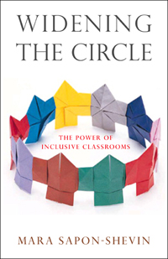

The Higher Education Task Force on Quality Inclusive Schooling works with its partners in SETRC, RSSC, SIG Districts, Teacher Centers and Parent Centers to bring about the change needed to create teachers who can help ensure that no child is left behind.

Members of the Task Force have taken on the challenge of transforming teaching practice by changing teacher preparation at their own institutions. Each of the programs represented on the Task Force has committed to designing and implementing a teacher preparation program leading to inclusive teaching practice.

Widening the Circle
Breakout Session I
12:45 to 1:45 pm

A. Systems Change and Inclusion
Presenters:
Superintendent Adele Bovard and Webster CSD staff

B. Advocating for Inclusion
Presenters:
Colleen Brown, Advocacy Center

C. Co-teaching at the Elementary Level
Presenters:
Dan Osborn and Brian Burley from Victor CSD

D. Co-teaching at the Secondary Level
Presenters:
Team from Naples CSD

Breakout Session II
2:00 to 3:00 pm.

E. Systems Change and Inclusion
Presenters:
Glenn Niles from Arkport CSD
Susan Bain-Lucey from Alfred-Almond CSD

F. Including Bilingual Students
Presenters:
Ron Acosta and Melissa Senn from RCSD

G. Co-teaching at the Elementary Level
Presenters:
Dan Osborn and Brian Burley from Victor CSD

H. Co-teaching at the Secondary Level
Presenters:
Team from Naples CSD

Registration formation

Registration Fee: $70 for one person
$300 for a team of five

Fee includes a copy of the book WIDENING THE CIRCLE, materials, continental breakfast and lunch. This session Coser aidable to districts. Districts outside of Monroe #1 BOCES please use cross contract.

Interpreters available upon request on the registration form under special accommodations.

Any questions? Please contact:

Ann Monroe-Baillargeon
Alfred University 607-871-2221

Cyndi Besig

Regional SETRC 585-249-7025
Jackie Czamanske
S3TAIR Coordinator 585-249-7859

Registration

Please register me for “Widening the Circle”
Name:________________________________
Phone: _______________________________
District/Organization: ___________________
Address: _____________________________
_____________________ Zip _____________
Please indicate sessions you plan to attend:
Session I choice: __ A __B __C __D
Session II choice: __ E __F __G __H

To register a team of 5 for $300 complete the above for the contact person and enter the additional 4 people below
Name | Session  I | Session  II
Special Accommodations: _______________
______________________________________
Fee: $70 for one (1), $300 for five (5)
Fax registration form along with PO, Coser or Cross Contact information to: 585-218-6267

If paying by check: make check payable to Monroe #1 BOCES and mail to:
Midwest Regional SETRC Office

15 Linden Park, Rochester, NY, 14625

Registration deadline: April 30, 2007

